11/11/2024 DSA PROBLEM DAY – 2
- CHECK EQUAL ARRAYS
PROGRAM:
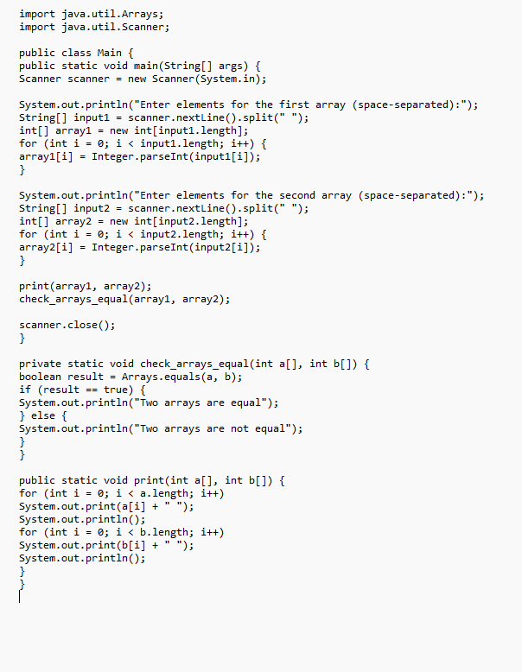
OUTPUT:
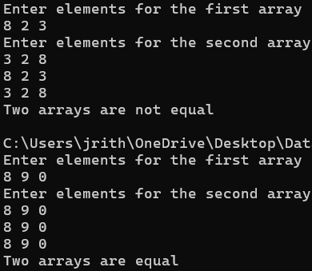
TIME COMPLEXITY: O(n+m)
- FLOOR IN SORTED ARRAY
CODE:
class Solution {
static int findFloor(int[] arr, int k) {
int low = 0, high = arr.length - 1;
int floorIndex = -1;

while (low <= high) {
int mid = low + (high - low) / 2;

if (arr[mid] <= k) {
floorIndex = mid;
low = mid + 1;
} else {
high = mid - 1;
}
}

return floorIndex;
}

}
Output:
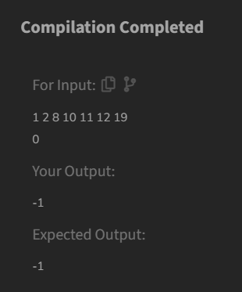
TIME COMPLEXITY: O(Logn)

- 0-1 KNAPSACK PROBLEM
CODE:
class Solution {
static int knapSack(int capacity, int val[], int wt[]) {
int n = val.length;
int[][] dp = new int[n + 1][capacity + 1];
for (int i = 1; i <= n; i++) {
for (int j = 1; j <= capacity; j++) {
if (wt[i - 1] <= j) {
dp[i][j] = Math.max(dp[i - 1][j], val[i - 1] + dp[i - 1][j - wt[i - 1]]);
} else {
dp[i][j] = dp[i - 1][j];
}
}
}

return dp[n][capacity];
}
}
OUTPUT:
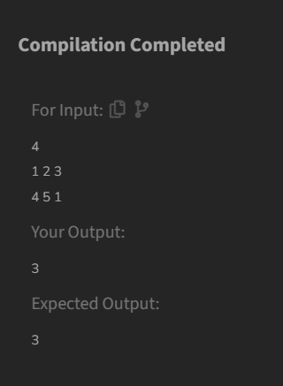

TIME COMPLEXITY: O(n*capacity)

- PALINDROME LINKED LIST
CODE:
class Solution {
boolean isPalindrome(Node head) {
if (head == null || head.next == null) return true;
Node slow = head, fast = head;
while (fast != null && fast.next != null) {
slow = slow.next;
fast = fast.next.next;
}

Node secondHalfHead = reverseList(slow);
Node firstHalfHead = head;
Node secondHalfIterator = secondHalfHead;
boolean isPalindrome = true;

while (secondHalfIterator != null) {
if (firstHalfHead.data != secondHalfIterator.data) {
isPalindrome = false;
break;
}
firstHalfHead = firstHalfHead.next;
secondHalfIterator = secondHalfIterator.next;
}

reverseList(secondHalfHead);

return isPalindrome;
}

private Node reverseList(Node head) {
Node prev = null;
while (head != null) {
Node next = head.next;
head.next = prev;
prev = head;
head = next;
}
return prev;
}
}
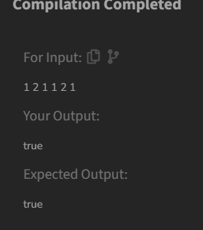
Time complexity: O(n)

- BALANCED TREE CHECK
CODE:
class Tree {

boolean isBalanced(Node root) {
return checkHeight(root) != -1;
}
private int checkHeight(Node node) {
if (node == null) {
return 0;
}
int leftHeight = checkHeight(node.left);
if (leftHeight == -1) return -1;

int rightHeight = checkHeight(node.right);
if (rightHeight == -1) return -1;
if (Math.abs(leftHeight - rightHeight) > 1) {
return -1;
}
return 1 + Math.max(leftHeight, rightHeight);
}
}
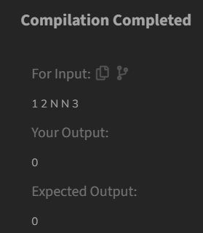
TIME COMPLEXITY: O(n)

- TRIPLET SUM IN ARRAY
CODE:
class Solution {

public static boolean find3Numbers(int arr[], int n, int x) {

Arrays.sort(arr);

for (int i = 0; i < n - 2; i++) {

int left = i + 1;
int right = n - 1;

while (left < right) {
int sum = arr[i] + arr[left] + arr[right];

if (sum == x) {
return true;
}

else if (sum < x) {
left++;
}

else {
right--;
}
}
}

return false;
}
}

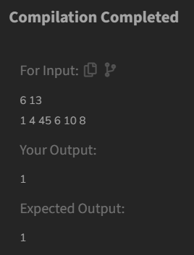
Time complexity: O(n^2)

